WORKTERRA
Friday, 24th March 2016
Gelson's Markets - Arden Group - Total compensation statement – Customization
[Requirement]:
Total Compensation Benefit Statements -
Regarding the comp statement, we would want to include salary, bonus, 401(k) match, paid vacation, personal days, paid sick time, employer benefit cost and taxes we pay on behalf of the employees.
Taxes to include: Social Security and Medicare, as well as Federal and State FUTA.
In addition to the 4 taxes mentioned, we have another – California Employment Training Tax.
Regarding sick, vacation and paid holidays we would like to keep these separate. We also provide personal days.
Please let me know if there is any other information that you need for this quote.
[Analysis]:
As per requirement below are list of fields to be included on Total compensation Statement
Display Fields | Available in WORKTERRA | NOT Available in WORKTERRA ( Need to implement)
Payroll & Benefits Fields | - Salary,  - PTO,  - Insurance benefits,  - Bonus,  - Employer benefit cost | - 401(k) match,  - Paid vacation,  - Personal days,  - Paid sick time,
Taxes to Include | - Federal  - State FUTA  - Social Security  - Medicare | - California Employment Training Tax

Available fields in WORKTERRA can be customized through Format Total Compensation Statement
As of now, we do not have ability to include additional fields on Total Compensation Statement page. We need ability to add additional fields to Total compensation Statement through ‘Additional Line Items’ section:
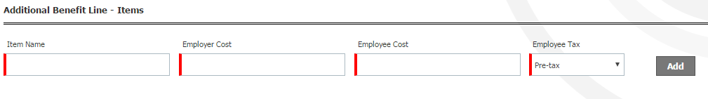

- As Items are added to additional fields section, there will be database columns getting added for these fields.
- There is no limit on adding additional fields on Line Items
- These fields will be available on Import Template. Values can be imported on these additional columns through Payroll template.
- The values inserted will be visible on Total Compensation Statement in Additional Line Items section.

- This will be generic implementation for all clients.

- The imported values will not be visible anywhere in system other than Total compensation Statement.

[Query]:
- Should the EE Cost, ER Cost, EE Tax (Pre Tax/Post Tax) be considered for additional Line items getting added through Format Total Compensation Statement, or there will be only one value associated with each line item?

Ans: Only ER cost is considered on Compensation statement.

